Tavistock Dementia Alliance: Action Plan
2022/2023

2022/2023

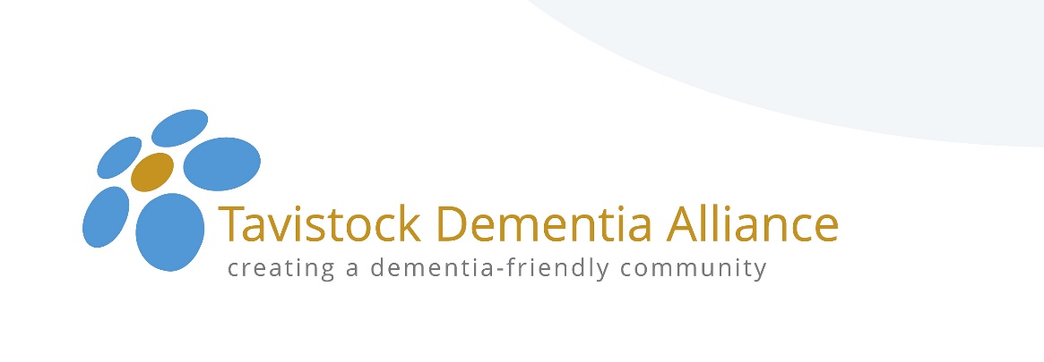

Vision of the Tavistock Dementia Alliance

Working in partnership and collaboration with others, facilitate and enable the development of a supportive ‘dementia-friendly’ community in Tavistock and the surrounding area.

Aims of the Alliance

The overall aims of the Alliance are to:

- Identify local needs of people with a dementia and their carers
- Develop greater awareness and understanding of dementia issues in our community
- Establish networks and links with businesses, service providers and people with dementia.
- Provide training and briefing to shops, businesses, social, faith, sporting and cultural organisations
- Aid communication and coordination of information by the provision of free accessible information.

Functions of the Alliance

The Alliance will achieve its overall aims by developing an Action Plan of activities with specific, clear and measurable objectives.

Action plan
The key actions are highlighted in the table below.

The measures/indicators and targets will be used to evaluate the impact of Alliance activity on an annual basis.

Action/Aim | Delivery | Measure/ Indicator | Target
Agree Action Plan for 2022/2023  with measures and targets. | To Meeting Attendees  (All members.) | Agree Action Plan | February 2022
Identify current local needs of those with a dementia and their carers in Tavistock and surrounding area – for inclusion in 2022/23 Action Plan | Through TMC and Admiral Nurse. Consult with Devon Carers  (volunteers?) | Survey(s) agreed and conducted - of Memory Café attendees? | March 2022
Contact all original signatories (shops/businesses/social groups) to Action Alliance and those recognised as ‘dementia-friendly’ arrange further briefing/training and potential ‘annual networking event’. | Through a Task and Finish group:  (Volunteers?) | Offer and deliver further briefing/training to original signatories and those who have achieved recognition.  Identification of nature and date of networking event. | Previous signatories and those currently ‘recognised’ as dementia-friendly contacted by November 2022  Event and its nature identified by March 2022
Continue marketing through Chamber of Commerce/BID, charitable and social organisations and personal contact. | Through a Task and Finish Group:  (Volunteers?) | Number of new organisations committing to training and recognition process to become ‘supporters’. | 10 by December 2022
Continue to produce Tavistock Alliance newsletters bi-annually to keep supporters/members/ public informed of activities | Through a ‘Task and Finish Group:  (Volunteers?) | Newsletters produced bi-annually. (And posted on website.) | By 10 June 2022
Present dementia awareness briefing sessions through Dementia Champions | Through Dementia Champions Task and Finish group.  (Names?) | Number of dementia-friends briefed in community. | 600 by April 2022
Focus on specific local organisations most used by those with a dementia and their carers to increase awareness and understanding of dementia. | Target Post Office, Dentist(s), Opticians, female and male hairdresser(s), and supermarket(s)  (Volunteers?) | Number of organisations recognised under Tavistock Alliance process as dementia-friendly. | 4 more by November 2019
Reduce social isolation and loneliness and increase health and well-being by including more social, faith and sports/recreational groups in 2022/23 priorities. | Target Churches, Walking Group, Swimming, Cycling, Golf Club, Photography Club etc  (Volunteers?) | Number of specific social, faith, sports and recreational groups contacted during 2022/23 | October 2022
Update website for Dementia Alliance to include local support, advice and information easily accessible and available free. | Through a Task and Finish Group.  (Tony P?) | Web site updated quarterly and google analytic data for web pages reported upon. | Dec 2022
Establish a more active on-line media presence through Facebook, Twitter etc. | Through a Task and Finish Group.  (Volunteers?) | On-line presence – all sites - maintained and updated regularly. | December 2022
Circulate and distribute more Tavistock Alliance leaflet/marketing materials to facilitate access to information and advice pre and post diagnosis. | Through a Task and finish Group – to cover ‘surrounding area’ of Tavistock  (Volunteers?) | Leaflets produced and distributed to all Doctors Surgeries, Library, Information Centre etc. | April 2022
Continue to provide, in collaboration with others, more dementia-friendly social and recreational activities/groups each month. | CST, VCST, CWA, Tovertafel  (Volunteers?) | Monitor number of individuals and groups attending activities quarterly. | December 2022
Support partnership and collaborative efforts to establish a central, easily accessible hub for health and social well-being in town. | Through Task and Finish Group  (Volunteers?) | Sustainable funding identified of and for partners/premises/ human resources. | Sep 2022
In collaboration with, for example Memory Café, Home Instead, Rotary Club, Livewell SW, GP surgeries and others to create further opportunities for those with a dementia and their carers to participate in stimulating activities. | Through Task and Finish Group.  (Volunteers?) | Establishment of regular activities for social and cognitive stimulation e.g. ‘Care and Share’; Singing for Fun | December 2022
Monitor and evaluate all activities and actions of the Dementia Alliance. | Through a Task and Finish Group  (Volunteers?) | Report produced on progress and outcomes against activities quarterly. (Annual report and presentation to AGM.) | Sep 2022

